Comparison of Arc Sentry vs AP Express Warehouses

# Inbound Comparative Analysis

s  
 *1. Base Inbound Costs:*  
 - **Arc Sentry**:  
 - Offers a flat rate for floor-loaded and palletized containers with devanning included.  
 - Lower costs for smaller containers, but with included services that might add value.  
 - **AP Express**:  
 - Slightly cheaper for 40’HQ containers, but additional charges can quickly add up depending on SKU count, carton count, weight, and other factors.  
   
 *2. Additional Services and Charges:*  
 - **Arc Sentry**: Includes comprehensive services like sorting, segregation, and stretch-wrapping in their per-pallet fee, potentially reducing the need for additional charges.  
 - **AP Express**: Has more granular charges for additional services (e.g., high SKU/carton count, no ASN), which could lead to higher costs depending on specific shipment characteristics.  
   
 *3. Potential Scenarios:*  
 - Scenario 1: High SKU/High Carton Shipments:  
 - **AP Express**: Might become expensive due to additional charges.  
 - **Arc Sentry**: Flat fees might be more economical.  
 - Scenario 2: Smaller, Simpler Shipments:  
 - **AP Express**: Could be cheaper if additional charges don’t apply.  
 - **Arc Sentry**: Still offers a straightforward, all-inclusive fee.

# Outbound Comparative Analysis

*1. Per Item/Unit Fees:*  
 - **Arc Sentry**:  
 - $1.95 per item for picking/scanning, plus $0.25 for "Eaches," which suggests additional charges for items stored in bins or requiring special handling.  
 - **AP Express**:  
 - $2.00 for the first unit in an order (under 40 lbs), plus $0.42 for each additional piece in the same package or $1.64 for an additional piece in an extra package.  
 Comparison: Arc Sentry's per-item fee is slightly lower than AP Express's base rate for the first unit but can become more expensive if additional handling is required (e.g., "Eaches"). AP Express has a tiered fee structure that could be more economical for larger orders with multiple items under 40 lbs.  
   
 *2. Labeling and Packaging Fees:*  
 - Arc Sentry:  
 - $0.65 per label for parcel labeling, $3.50 for overpack box, and $15.00 for pallet wrap and prep.  
 - AP Express:  
 - $0.39 per strike for marking/tagging/labeling.  
 Comparison: AP Express offers lower costs for basic labeling/tagging at $0.39 per strike. However, Arc Sentry's fees are likely higher due to the more extensive services (parcel labeling and overpacking), which might be required for complex shipments.  
   
 3. Order-Level Fees:  
 - Arc Sentry: Does not explicitly list a base order processing fee but focuses on per-item charges.  
 - AP Express:  
 - $2.00 for the first unit in an order under 40 lbs.  
 - $4.98 for the first unit in an order between 40 lbs and 150 lbs.  
 - Returns Processing Fee: $3.86 per order.  
 Comparison: AP Express clearly defines its order processing fees with a tiered structure based on weight, which could be advantageous for orders containing heavier items. Arc Sentry seems to focus on individual handling and labeling fees, which might lead to lower costs for small, simple orders but could escalate for larger, more complex shipments.

# Cost Comparison Chart

The following chart illustrates the cost comparison between Arc Sentry and AP Express across different shipment scenarios:

# Cost Comparison Chart

The following chart illustrates the cost comparison between Arc Sentry and AP Express across different shipment scenarios:

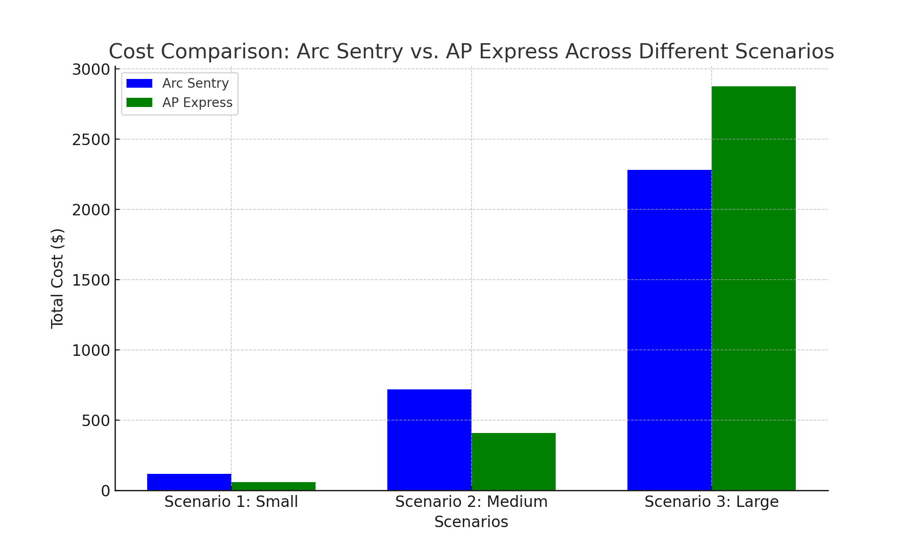

# Conclusion

Based on the scenarios analyzed:  
 - Arc Sentry appears to offer lower per-item fees but includes additional charges for handling and packaging that could increase the overall cost, especially for complex orders.  
 - AP Express provides a more structured fee schedule that might be more predictable, especially for larger orders with multiple items, though the base rates are slightly higher.  
  
 This analysis is a simulation based on the data provided and should not be considered definitive. Actual costs may vary depending on specific circumstances, and it's recommended to consult with both Arc Sentry and AP Express for precise pricing tailored to your needs.

# Scenario Simulation Details

## Scenario 1: Small Shipment

### Assumptions:

- 1 pallet with a single SKU.  
- 50 items, all weighing under 40 lbs.  
- Stored for 1 week.  
- Minimal additional services, no extra charges for high SKU or carton counts.

### Purpose: To compare costs for a simple, small-scale shipment with minimal complexity.

## Scenario 2: Medium Shipment

### Assumptions:

- 5 pallets with 3 SKUs.  
- 300 items, all weighing under 40 lbs.  
- Stored for 2 weeks.  
- No additional charges for high SKU or carton counts.

Purpose: To evaluate the cost-effectiveness for a moderate shipment size with some complexity in terms of multiple SKUs.

## Scenario 3: Large Shipment

### Assumptions:

- 10 pallets with 10 SKUs.  
- 1000 items, including 200 heavy items (40-150 lbs).  
- Stored for 3 weeks.  
- Additional charges for high SKU count and heavy items where applicable.

Purpose: To assess costs for a large, complex shipment involving multiple SKUs and heavier items.

***Note :****These scenarios are designed to simulate potential real-world shipping and storage situations, providing a comparative cost analysis between the two warehouses based on the specific parameters assumed.*

### ****Potential Hidden Costs to Consider:****

1. **Service-Level Agreements (SLAs) and Penalties:**
   * **AP Express:** If they have strict SLAs, missing deadlines (e.g., providing Advanced Shipment Notices, scheduling pickups/deliveries) could lead to penalties. These costs might not be explicitly mentioned in the rate sheet but could significantly impact overall costs.
   * **Arc Sentry:** The $100 blind receipt fee for missed appointment windows is an example of a potential extra cost. There could be other similar fees tied to service levels.
2. **Integration and System Fees:**
   * **Arc Sentry:** They charge a weekly systems fee ($49) for WMS setup, software, and IT support, which might not be clearly understood during initial costing. Additionally, if you require integration with external systems, this could involve additional costs.
   * **AP Express:** While they don't list a similar fee, it's possible they may charge for advanced IT support, integration with third-party systems, or client portals.
3. **Project-Specific Labor Costs:**
   * **Arc Sentry:** Charges for project work ($65 per hour) and administrative work ($85 per hour) could add up if special projects, cycle counts, or stock consolidations are needed. These are typically not included in standard storage and handling fees.
   * **AP Express:** If they handle similar tasks, they might either absorb these costs into overhead or charge them as additional fees, depending on the complexity and frequency of the required services.
4. **Minimum Billing Requirements:**
   * **Arc Sentry:** The $6,500 weekly minimum billing requirement could be a significant hidden cost for smaller operations that do not meet this threshold. This could lead to paying for unused services or space.
   * **AP Express:** If they have a similar minimum billing requirement, it could be buried in contract terms and not immediately apparent from the rate sheet.
5. **Custom Services and Special Handling:**
   * **Arc Sentry:** Charges for special handling, kitting, tagging, and other value-added services might apply depending on the specific needs of your operation. These could be billed at higher rates than standard services.
   * **AP Express:** They charge for specific tasks like marking/tagging/labeling ($0.39 per strike), but other custom services might also involve additional, less transparent fees.
6. **Operational Efficiency Costs:**
   * **Delays and Inefficiencies:** If either provider has slower processing times, poor coordination, or inefficient systems, these could result in longer storage times, delayed shipments, and increased overall costs. Such costs are often indirect and not explicitly stated but can significantly affect the bottom line.